You are given the strings key and message, which represent a cipher key and a secret message, respectively. The steps to decode message are as follows:
- Use the first appearance of all 26 lowercase English letters in key as the order of the substitution table.
- Align the substitution table with the regular English alphabet.
- Each letter in message is then substituted using the table.
- Spaces ' ' are transformed to themselves.
- For example, given key = "happy boy" (actual key would have at least one instance of each letter in the alphabet), we have the partial substitution table of ('h' -> 'a', 'a' -> 'b', 'p' -> 'c', 'y' -> 'd', 'b' -> 'e', 'o' -> 'f').
Return the decoded message.

Example 1:
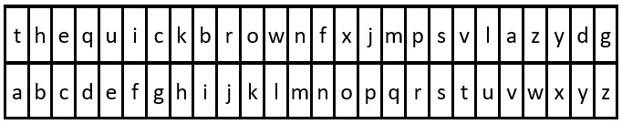
Input: key = "the quick brown fox jumps over the lazy dog", message = "vkbs bs t suepuv"
Output: "this is a secret"
Explanation: The diagram above shows the substitution table.
It is obtained by taking the first appearance of each letter in "the quick brown fox jumps over the lazy dog".
Example 2:
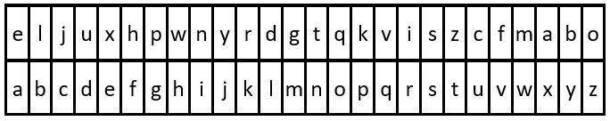
Input: key = "eljuxhpwnyrdgtqkviszcfmabo", message = "zwx hnfx lqantp mnoeius ycgk vcnjrdb"
Output: "the five boxing wizards jump quickly"
Explanation: The diagram above shows the substitution table.
It is obtained by taking the first appearance of each letter in "eljuxhpwnyrdgtqkviszcfmabo".

Constraints:
- 26 <= key.length <= 2000
- key consists of lowercase English letters and ' '.
- key contains every letter in the English alphabet ('a' to 'z') at least once.
- 1 <= message.length <= 2000
- message consists of lowercase English letters and ' '.

